**PROJECT #2: Performance Evaluation of a Space Division Packet Switching**

**COURSE: ESE 546 Network Algorithms, Fall 2015, Prof. T. Robertazzi**

**NAME: PREM SHANKAR**

**STUDENT ID: 110500038**

**Description of Program**

The project aims at producing a discrete event simulation of 3x4, 4x5, and 5x6 cross bar switches. The probability that an input has a single packet on it is p. One packet fills one slot. The input packet is equally likely to go on any output. If two or more than two packets from different inputs arrive at same output slot, only one is chosen randomly and the remaining are discarded.

The project is implemented in two phases namely, theoretical and simulation. In simulation part, discrete event simulation for the scenario is implemented. The program mimics the operation of the network and collects the statistics. That is, for each size crossbar, in each slot, packets are randomly generated for the crossbar inputs. Thereafter, amongst the packets available on input are randomly allowed to go to output. If there are multiple input packets on an output slot, only one is selected randomly and rest are dropped. The process is repeated for 5000 time slots to obtain smooth curves. The same procedure is followed for probability values ranging from p =0.02 to 1. Throughput is calculated for each value of p. Finally, a graph is plotted for throughput for each crossbar versus probability values.

a Inputs

b Outputs

The next phase of project deals with obtaining theoretical values for each probability values ranging from 0.02 to 1. The equation used to calculate theoretical value of throughput is given below:

Throughputoutput =

Thereafter, a graph is plotted for this case too which is essentially same as that obtained for simulation case.

**FLOWCHART**

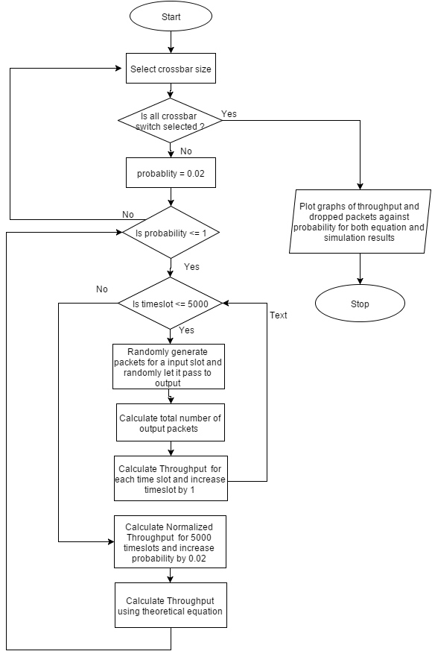

**SOURCE CODE**

**Name of Language Used: MATLAB**

%% Theoretical Part

input = 3;

output = 4;

prob = 0.02:0.02:1;

throughput = zeros(3,50);

for i = 1:3

for p = 1:50

%Calculation of theoretical throughput

throughput(i,p) = (1-(1-(prob(p)/output))^input);

end

input = input + 1;

output = output + 1;

end

t1 = throughput(1,1:50); %Throughput for 3x4

t2 = throughput(2,1:50); %Throughput for 4x5

t3 = throughput(3,1:50); %Throughput for 5x6

%% Simulation Part

input = 3;

output = 4;

throughput_sim = zeros(3,50);

for i = 1:3 %For each of the crossbar

l = 1;

t = 0;

for p = 0.02:0.02:1

for j = 1:5000

input_packet = (rand(1,input)) <= p ; %Generate input packets

o = zeros(1,output);

for k = 1:input

if(input_packet(k) == 1 )

o(randi([1 output],1,1)) = 1; %Randomly select output packet

end

end

t = t + sum(o);

end

t = t/(5000 * output); %Calculate throughput for each probability

throughput_sim(i,l) = t;

l = l+1;

end

input = input + 1;

output = output + 1;

end

%% Plot Graphs

figure

p1 = plot(prob,throughput_sim(1,1:50),'*g',prob,throughput_sim(2,1:50),'xk',prob,throughput_sim(3,1:50),'bo',prob,t1,':g',prob,t2,':k',prob,t3,':b');

title('Simulation vs Theoretical');

xlabel('Probability');

ylabel('Throughput');

p1(1).LineWidth = 2;

p1(2).LineWidth = 2;

p1(3).LineWidth = 2;

p1(4).LineWidth = 2;

p1(5).LineWidth = 2;

p1(6).LineWidth = 2;

**GRAPH**

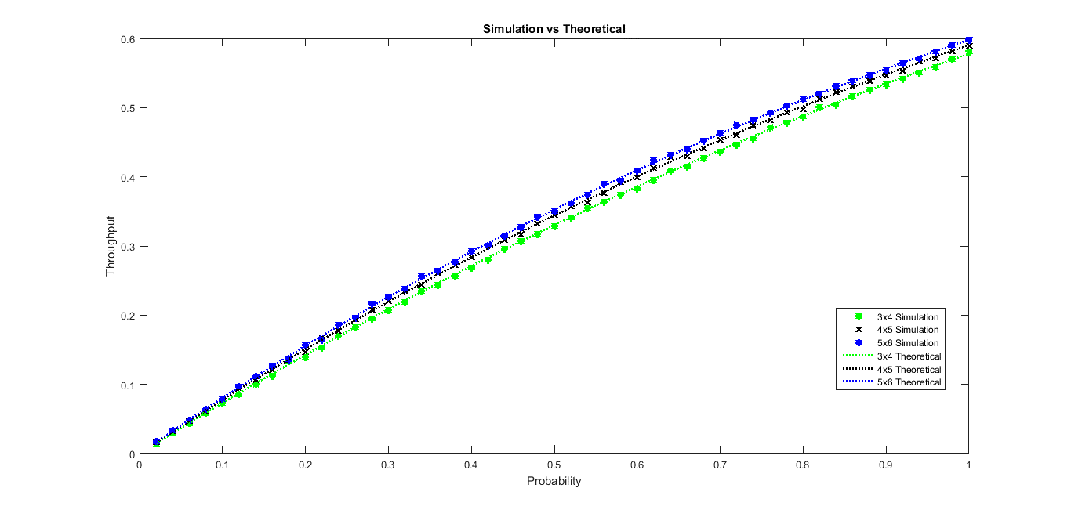

**GRAPHS**

1. **Throughput VS Probability (Theoretical)**

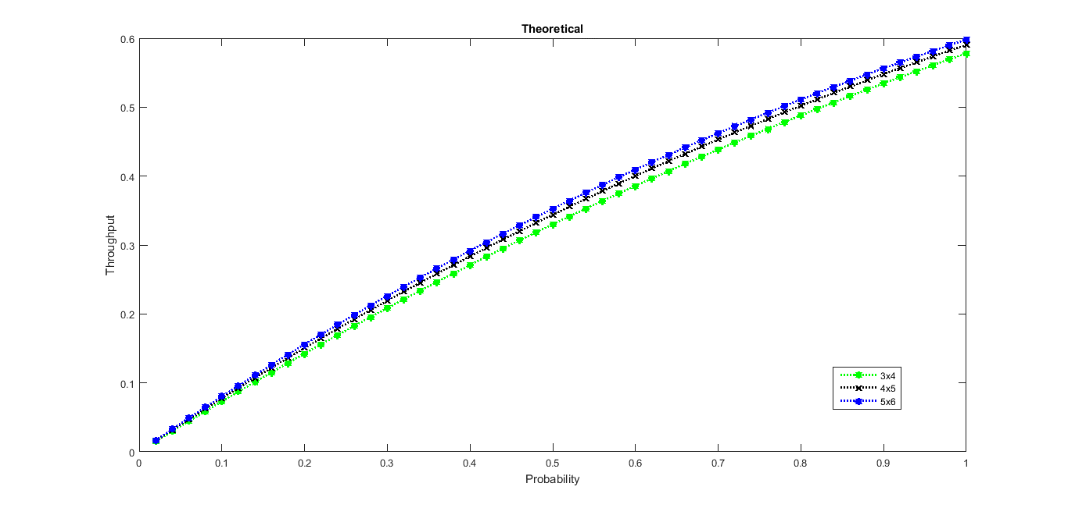

1. **Throughput VS Probability (Simulation)**

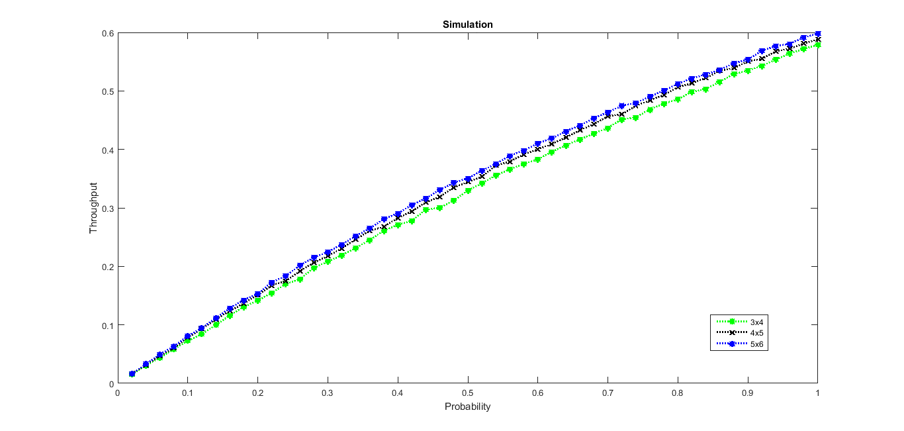

**CONCLUSION**

The performance of space division packet switching for a crossbar switch can be evaluated on the grounds of probability of arrival of packets on input as well as outputs. As the probability of packets arriving on input slot increases, throughput of the system increases. This can be well verified from the graphs we have obtained from simulation and theoretical results.

If more packets arrive at the same output slot, only one packet can be let through. Others are dropped. Therefore, the increase in dropped packets at output slot results in reduced throughput thereby decreasing the performance of the system.

The throughput of the crossbar switch also increases as the output slots increases as can be observed from the graph.